EECS 495 Homework Assignment 2
Yongchi Zhang
Problem 1
Solution:
a. Correct.
Using the Transitivity Rule, we have:
Then we use the Union Rule:
So (a) is correct.

b. Correct.
Using the Augmentation Rule:
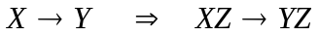
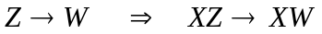
Then we use the Union Rule, and get:
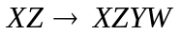
Then we use the Decomposition Rule, and get:
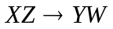
So (b) is correct.

c. Incorrect.
The counterexample is as follows:

X | Y | Z
x1 | y1 | z1
x1 | y2 | z1

From this relation we can see that 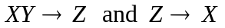 , but Z does not determines Y.

Problem 2
Solution:
Consider first 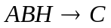
From F we can have 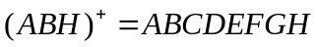, so we have ABH is superkey.
So does not cause a violation of BCNF.
Consider 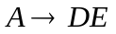
From F we can have 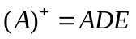, so we have A is not superkey.
So causes a violation of BCNF.
So we decompose R into R1 and R2 where R1(A,D,E) and R2(A,B,C,F,G,H)
There is only F=() in R1. So R1 satisfies BCNF.
Consider R2. Consider 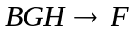
From F we can have 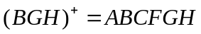, so we have BGH is superkey.
So does not cause a violation of BCNF.
Consider 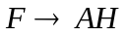
From F we can have 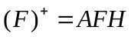, so we have F is not superkey.
So causes a violation of BCNF.
So we decompose R2 into R3 and R4 where R3(F,A,H) and R4(B,C,F,G)
There is only F=() in R3. So R3 satisfies BCNF.
There is F=(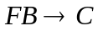,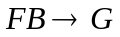) in R4. And 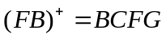. So we have BF is superkey.
R4 satisfies BCNF.

So we finally decompose R into: R1(A,D,E) , R3(F,A,H) , R4(B,C,F,G)

Problem 3
Solution:
No. Because the relation of attribute A and B can be many to many. It means A does not determine B and B does not determine A. In this case, the instance r of the schema R is not in BCNF.

Problem 4
Solution:
1)
1. B is extraneous in 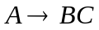 because
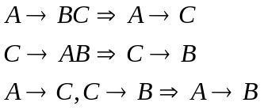
So set is now 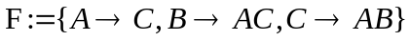
2. C is extraneous in 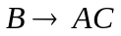 because
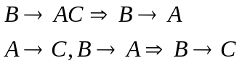
So set is now 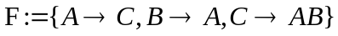
3. A is extraneous in 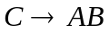 because
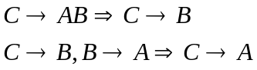
So set is now 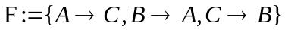
So the canonical cover is 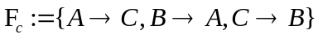
2)
1. C is extraneous in because
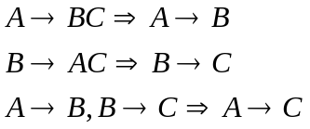
So set is now 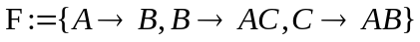
2. A is extraneous in because
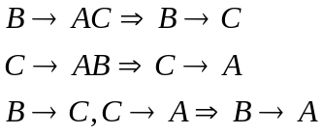
So set is now 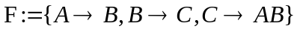
3. B is extraneous in because
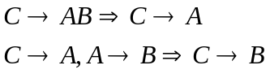
So set is now 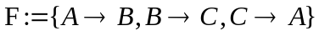
So the canonical cover is 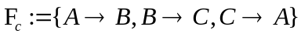

Problem 5
Solution:
a) 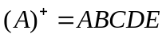 and there is no real subset. So A is the candidate key of R.
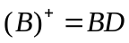 So B is not the superkey of R.
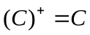 So C is not the superkey of R.
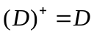 So D is not the superkey of R.
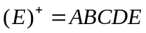 and there is no real subset. So E is the candidate key of R.
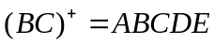 and there is no real subset of (BC) that can be superkey. So BC is the candidate key of R.
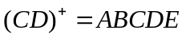 and there is no real subset of (CD) that can be superkey. So CD is the candidate key of R.
So the candidate keys of R are A,E,BC,CD
b) 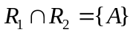
And we have concluded that A is the candidate key of R.
So
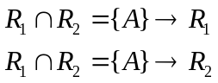
So the decomposition of R into R1 and R2 is a lossless join.

Problem 6
Solution:
a) The precedence graph is :
T1 | T2 | T3
 | R2(A)
R1(B)
 | W2(A)
 | R2(B)
 |  | R3(A)
W1(B)
 |  | W3(A)
 | W2(B)
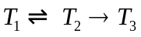
The schedule is conflict serializable if and only if the precedence graph has no cycles. And because T1 and T2 make a cycle, the schedule is not conflict serializable.

b) The example is as below:

T1 | T2
Read(X)
X=X-50
 | Read(X)
 | Temp=X*0.1
 | X=X-Temp
 | Write(X)
 | Read(Y)
Read(Y)
Y=Y+50
Write(X)
Write(Y)
 | Y=Y+Temp
 | Write(Y)

